Solar Oven Project Report

Shelby Nelson, Isabella Martinez-Lugo, Joshua Silverio, Jarod Yancy

ENGR 102B

November 4th, 2016

**Table of Contents**

Abstract………………………………………………………………………….3

Introduction……………………………………………………………………...3-4

Design Theory and System Model………………………………………………4-14

Design Requirements…………………………………………………………....14-15

Design Description……………………………………………………………...14-22

Design Justification………………………………………………………22-24

Test Procedure…………………………………………………………………...24-25

Test Results……………………………………………………………………...26-29

Team Dynamics………………………………………………………………….29

Design Critique and Summary…………………………………………………..29-30

References………………………………………………………………………..31

Appendices……………………………………………………………………….32-40

**Abstract**

Scientists and engineers of the 21st century carry the onus of developing renewable energy technology in order to combat climate change. Although it is often overlooked, creating ways to harness renewable energy in a cost efficient and convenient way is essential for ensuring the survival of the human race. The Solar Oven Design Project allowed our team to gain engineering experience by emulating the process that professional engineers use while producing a product—in this case, a solar oven. The purpose of our project was to design, build, test, and analyze a cost efficient solar oven that could reach an internal oven temperature hot enough to cook a biscuit. We used an Excel model in order to obtain optimal dimensions for our oven, including an inner oven chamber which measured 13.3 cm x 13.3 cm x 5.65 cm, an outer box which measured 31.0 cm x 31.0 cm x 21.0 cm, four trapezoidal reflectors which had a height to bottom base width ratio of 13.3 cm to 21.0 cm, and an oven window which measured 13.3 cm x 13.3 cm. Our Excel model predicted that the internal temperature of our oven would reach 189.6℃; however, our model was unable to account for ambient conditions such as wind and cloud coverage decreasing the oven’s temperature and thus our actual oven temperature varied from the predicted model. Despite these variants, the project was still a success.

**Introduction**

While the overall goal of this project was to construct a solar oven, our team was left with much more than a functional product following the Solar Oven Throwdown. We learned that designing a product is very different from actually building it and that the planning phase is critical in order to account for as many factors as possible. This decreases the likelihood that an unforeseen event will drastically alter the product or its faculty. Building the solar oven required patience and diligence because mistakes were made during the construction of our first oven, resulting in crooked cardboard pieces which when assembled, left several gaps through which heat could escape. Our team could learn from its mistakes through the mutual effort of each individual team member using their mathematical backgrounds and problem-solving skills to refine the oven design. Ultimately, each member developed an understanding of the reciprocity and teamwork needed to construct a functional product.

We were motivated by our desire to innovate problematic systems to better the lives of others. A clear majority of the populations in developing countries do not have access to clean water or pasteurized foods. Solar ovens do not require electricity in the traditional sense and can be powered by something that everyone has access to: the sun. This makes solar ovens an accessible and convenient product which can improve the lives of millions of people around the world.

**Design Theory and System Model**

For both solar ovens designed in this project, the predicted oven temperature is the temperature when the oven reaches equilibrium, meaning that the temperature inside of the oven can no longer rise because the energy flowing into the oven is equal to the energy flowing out of the oven. The Excel model was the mechanism used to establish the oven dimensions that optimized the internal oven temperature. The following equations demonstrate how as the energy that flows into the oven increases, so does the energy that flows out.

Energyin = Energyout (Ein = Eout) (1)

Powerabsorbed = Powerout (Pabsorbed = Pout) (2)

There are three types of heat transfer which come into play during the process of heating up a solar oven. The power that enters the oven is a form of radiation which occurs when electromagnetic waves meet a surface. When the sun’s waves touch a surface, the waves transfer heat onto the surface. Applying this to a solar oven, electromagnetic radiation from the sun hits the reflectors, enters the oven chamber through the Mylar window, heating the oven. The heat transfer for our second oven yielded a higher temperature because the aluminum foil was smoother, making the solar incident more effective.

Reflectors

Electromagnetic radiation

Cooking chamber

The energy that goes into the oven (Pabsorbed) is related to the solar power radiated into the oven through the window. This is the solar power density *Io*(W/m2) at the surface of the earth multiplied by the area of the window that the sun’s rays touch. Keep in mind that this is the area of the window that is perpendicular to the sun’s rays. The area of the window is defined as Aw=L*W, however this diagram demonstrates that the area seen by the sun is actually equal to y*W because we know that y=Lsin(*θs* +𝛽) due to trigonometric laws. When you combine these equations, you are left with

Pincident to window = IoW*Lsin(*θs* +𝛽)

where: Io = incident solar power density (W/m2)

W= window width (m)

L = window length (m)

*θs* = the angle the sun’s rays make with respect to the ground

*β* = the angle the window makes with respect to the ground

Because *θs* is constantly changing throughout the day as the sun rotates around Earth, we must adjust the angle so that *θs* + *β* is always equal to 90°, and so *θs*cannot be considered a design variable. *β* on the other hand, is a design variable because we have direct control over its measurements. It is critical that *θs* + *β* = 90° throughout the entirety of the experiment so that the sun’s rays strike normal to the window which will mathematically maximize the sine function. To ensure that the window is perpendicular to the sun’s rays, we must tilt the top surface of the oven and use a protractor to measure the appropriate *β*.

The power that is transmitted through the oven window must also be calculated and this can be done by multiplying the optical transmission of the window material by the incident to the window. This results in the equation

Ptransmitted = *τ* n * Pincident to window

where: *τ* = the optical transmission coefficient of the window material (0 ≤ *τ* ≤ 1)

n = the number of Mylar layers used for the window

The domain for *τ* can be explained by the fact that having a *τ* value of 0 would mean that the window material is completely transparent which would allow an abundant amount of radiation to go through the window and heat up the oven, however because Ein = Eout, more heat would escape through the window. Having a *τ* value of 1 would mean that the window material is completely opaque and would not allow any radiation to permeate the oven window and heat up the chamber. Thus, *τ* should be 0 ≤ *τ* ≤ 1 and in this case, is 0.92.

We can calculate the power that is absorbed by the oven walls by knowing that the power that is transmitted through the window multiplied by the absorption factor of the walls is the power absorbed. This is defined by the equation

Pabsorbed = a*Ptransmitted

where: a = the absorption factor of the cavity walls

Combining these equations derives the formula for the power absorbed which is as follows:

Pabsorbed = Io*Aw* *τ* * *α* *sin(*θs* + *β*)

To maximize the power absorbed, the oven should have two oven windows so that *τ* becomes *τ* 2. Reflectors provide the oven with an additional gain G of heat energy, based on the equations:

*Pabsorbed with a reflector = G* ·*Pabsorbed without a reflector*

*Pabsorbed with a reflector = Io AW*· *G* ·*τ · α · sin( θs + β)*

The sun hits the earth creating an angle of incidence with the surface of the reflectors 𝛼. The reflector also has an angle which is denoted by Ω. The angles at which these were bent depended on our M/L ratio which was 2.8 for the first oven and 3.0 for the second oven. The M/L ratio was the length of the reflector M over the length of the oven window L. From this we calculated that our oven should be set with an Ω of 27.1o and an α of 62.9o. Although, the α angle was not properly calculated due to the restrictive nature of backpacks to support our oven. We believe this may have caused the power absorbed to be less than that which was predicted in the Excel model.

The process in which aluminum foil was put onto the reflectors had a major effect on the overall internal oven temperature. If the oven had smooth shiny foil, it would be more reflective which would allow for more solar energy to enter the inner oven chamber. The reflectivity of the reflector R could have been assigned a value between (0.9 - 0.5) the most realistic of which was 0.7, denoted to be almost completely smooth. The value of 0.7 was used for both ovens that were constructed. It is known that:

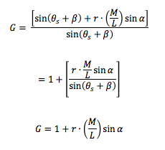Pabsorbed with a reflector = G · Pabsorbed without a reflector

Through substitution, we can derive that:

However, this formula accounts for one reflector, we then added four to the numerator to account for all four reflectors.

All of the previous equations were needed to find the amount of heat entering the oven; however, energy is also lost within the oven during the test and is indicative of heat transfer. This is seen in the equation:

*P = U* · *A* · (*Tsurface ‒ Tregion into which power flows*)

where: *U* = overall heat transfer coefficient (W/m2·°C)

*A* = area through which the heat flows (m2*)*

*T* = temperature (°C)

When heat is transferred from one surface to another, the power that is transferred depends on the area and heat transfer coefficient of the surfaces. The smaller that both of these variables are, the hotter the inner oven chamber will be. In our first oven, the dimensions were 13.3 cm x 13.3 cm. Although this window could have been made smaller in size, these dimensions allowed enough heat to get into the oven chamber while still having a small enough surface area to minimize the power lost through the heat transfer.

*Pout =* (*Usb* · *Asb* + *Uw* · *Aw*)(*Tio* ‒ *Tambient*)

*Usb* = the overall heat transfer coefficient for the sides and bottom of the interior oven chamber

*Asb* = the total area of the sides and bottom of the interior oven chamber

*Uw* = the overall heat transfer coefficient for the window

*Aw* = the area of the window

*Tio* = the temperature in the interior chamber of the oven

*Tambient* = the temperature of the air surrounding the oven (the outdoor temperature

on testing days)

The window described above has a heat transfer coefficient and is dependent on two variables. These variables include the number of Mylar sheets used for the window, and the temperature of the oven. The *Uw* values were given by the Solar Oven Basics Document, and are provided below for various Tio values.

|  |  |  |
| --- | --- | --- |
| Uw, single (W/(m2*°C) | Uw, double (W/(m2*°C*) | Empirical Tio |
| 10.10 | 4.88 | 66 |
| 13.90 | 6.69 | 93 |
| 18.66 | 8.96 | 121 |
| 24.34 | 11.74 | 149 |
| 31.60 | 15.20 | 177 |
| 40.11 | 19.35 | 204 |

The heat transfer coefficient for the entire oven is defined as *U*, and for the Pout equation it is *Usb* to represent the heat transfer of the sides and bottom of the solar oven. *Usb*, also depends on the type of material used, but also depends on the thickness of the material used. The relationship between the heat transfer coefficient and the thickness of the material used is shown by the equation *U = k/x*, where x is the thickness and k is the heat conductivity of the material used. It is important to note that this relationship holds true when only one material is used. When more than one material is involved (for example, the cardboard for the inner chamber, the cardboard for the larger box, and the newspaper insulation), all the materials have a certain combined insulation capability that reduces the overall heat transfer and is defined by:



R represents the resistance to the heat transfer, and it should ideally be as large as possible to promote heat to stay inside the oven.

When heat transfer occurs, its natural path goes from warm surfaces to cooler ones by contacting the surfaces. This process is known as “conduction.” For our solar oven, conduction caused heat to escape the oven chamber and move into the insulation towards the cooler outer box. As it is not ideal to lose heat from the oven chamber, the insulation was chosen carefully to inhibit the amount of heat transfer in the oven.

Newspaper was chosen as the insulator because it has a low thermal conductivity, which does not promote heat transfer nor conduction within the oven. The reason why newspaper is a good insulator is because there a large amount of air particles trapped inside the paper fibers. Gas is a poor conductor of heat because as it rises when heated, a convection current is created and conduction lost strength to this convection. The newspaper used was waded into medium-sized pieces in the first oven design, but in the second design, the newspaper was shredded into smaller pieces to allow more newspaper to surround the oven chamber. This ultimately decreased heat transfer that occurred during the first oven test. The insulation variables for both oven designs are provided below.

|  |  |  |
| --- | --- | --- |
|  | Design 1 Variables |  |
| x1 | 0.003 | Inner Cardboard wall thickness (m) |
| x2 | 0.07 | Insulation thickness (m) |
| x3 | 0.003 | Outer Cardboard wall thickness (m) |
| k1 | 0.064 | Inner Cardboard wall thermal conductivity (W/(m2*˚C)) |
| k2 | 0.123 | Insulation thermal conductivity (W/(m2*˚C)) |
| k3 | 0.064 | Outer cardboard wall thermal conductivity (W/(m2*˚C)) |

|  |  |  |
| --- | --- | --- |
|  | Design 2 Variables |  |
| x1 | 0.003 | Inner Cardboard wall thickness (m) |
| x2 | 0.09 | Insulation thickness (m) |
| x3 | 0.003 | Outer Cardboard wall thickness (m) |
| k1 | 0.064 | Inner Cardboard wall thermal conductivity (W/(m2*˚C)) |
| k2 | 0.123 | Insulation thermal conductivity (W/(m2*˚C)) |
| k3 | 0.064 | Outer cardboard wall thermal conductivity (W/(m2*˚C)) |

When the data above is substituted into the *Usb*formula, the *Usb* value of oven 1 was 1.51 W/(m2*˚C) and the *Usb* value for oven 2 was 1.21 W/(m2*˚C). Since Oven 2 displays a lower heat transfer coefficient, more heat will be kept inside the chamber of oven 2.

The final step is to find the internal oven chamber temperature, which is the temperature inside the oven when it reaches thermal equilibrium. Since the internal oven temperature is no longer rising at this equilibrium, the temperature is said to be a maximum and can be modeled by setting the power absorbed by the oven equal to the power leaving the oven. By defining Pin and Pout with the newly found variables above, the equation is as follows:



The dimensions and values for the variables of both ovens are provided below.

**Oven 1:**

|  |  |  |  |  |  |
| --- | --- | --- | --- | --- | --- |
| **Input Parameters** | |  |  | | |
| τ | | 0.92 | Transmissivity for a single layer of Mylar | | |
| α | | 0.90 | Absorption factor of oven chamber and contents | | |
| r | | 0.70 | Aluminum foil reflectivity | | |
| Tambient | | 24.00 | Ambient temperature °C | | |
| Io | | 915.00 | Solar power density watts/m2 | | |
| θs | | 27.10 | Angle of sun’s rays with respect to the ground (degrees) | | |
| β | | 62.90 | Angle of the top surface of the oven with respect to the ground (degrees) | | |
| L | | 0.133 | Length of Oven Window (m) | | |
| W | | 0.133 | Width of Oven Window (m) | | |
| n | | 2 | # of Mylar windows | | |
| M/L | | 2.8 | Ratio of the reflector length to the window length | | |
| Uchamber | | 0.001 | Volume of the oven chamber (m3) | | |
| Aw | | 0.01769 | Area of the window (m2) | | |
| Asb | | 0.04776 | Area of the sides and bottom of the cooking chamber (m2) | | |
| Usb | | 1.50862 | Heat transfer of the sides and bottom of the cooking chamber (W/(m2*°C)) | | |
| M | | 0.3724 | Length of the reflectors (m) | | |
| α | | 17.1568 | Angle of sunlight with respect to the reflectors (degrees) | | |
| Ω | | 107.157 | Lid angle (degrees) | | |
| G | | 5.22291 | Gain from adding reflectors | | |
| h | | 0.05653 | Height of Oven Chamber (m) | | |
| Uw, single (W/(m2*°C) | Uw, double (W/(m2*°C*) | | | Tio(˚C) |
| 10.10 | 4.88 | | | 430.5869646 |
| 13.90 | 6.69 | | | 362.2156682 |
| 18.66 | 8.96 | | | 303.310331 |
| 24.34 | 11.74 | | | 254.2081711 |
| 31.60 | 15.20 | | | 212.8811956 |
| 40.11 | 19.35 | | | 179.4168086 |

**Oven 2:**

|  |  |  |
| --- | --- | --- |
| **Input Parameters** |  |  |
| τ | 0.92 | Transmissivity for a single layer of Mylar |
| α | 0.90 | Absorption factor of oven chamber and contents |
| r | 0.70 | Aluminum foil reflectivity |
| Tambient | 32.50 | Ambient temperature °C |
| Io | 779.00 | Solar power density watts/m2 |
| θs | 27.10 | Angle of sun’s rays with respect to the ground (degrees) |
| β | 62.90 | Angle of the top surface of the oven with respect to the ground (degrees) |
| L | 0.133 | Length of Oven Window (m) |
| W | 0.133 | Width of Oven Window (m) |
| n | 2 | # of Mylar windows |
| M/L | 3 | Ratio of the reflector length to the window length |
| Uchamber | 0.001 | Volume of the oven chamber (m3) |
| Aw | 0.01769 | Area of the window (m2) |
| Asb | 0.04776 | Area of the sides and bottom of the cooking chamber (m2) |
| Usb | 1.21145 | Heat transfer of the sides and bottom of the cooking chamber (W/(m2*°C)) |
| M | 0.399 | Length of the reflectors (m) |
| α | 16.3065 | Angle of sunlight with respect to the reflectors (degrees) |
| Ω | 106.307 | Lid angle (degrees) |
| G | 5.34517 | Gain from adding reflectors |
| h | 0.05653 | Height of Oven Chamber (m) |

|  |  |  |
| --- | --- | --- |
| Uw, single (W/(m2*°C) | Uw, double (W/(m2*°C*) | Tio(˚C) |
| 10.10 | 4.88 | 421.6319907 |
| 13.90 | 6.69 | 350.9246172 |
| 18.66 | 8.96 | 291.827796 |
| 24.34 | 11.74 | 243.801508 |
| 31.60 | 15.20 | 204.2207556 |
| 40.11 | 19.35 | 172.7174864 |

Because Uw is a function of Tio, the predicted oven chamber temperature must be solved graphically. The results of the Uw (x values on the graph) and Tio (y values on the graph) are shown below for both ovens.

**Design Requirements**

While designing, and constructing our oven, there were many constraints that were placed on our team. For example, the oven chamber’s volume had to be equal to 1000 cm3 and the height or depth of the cooking chamber had to be at least 5 cm in length. The oven must be able to stand on its own along with the cost being no more than $20.00. In order to simplify the calculations, the window opening also had to be a square shape with a width equal to its length. Furthermore, another constraint was that the oven must be easily accessible to place both a biscuit and a thermometer inside. The thermometer would be used to determine the temperature inside the oven chamber. The last constraint put on the oven was that the M/L ratio had to be less than or equal to 3, the M/L ratio is defined as the length of the reflector divided by the oven window length. This restricted either the oven window or reflector length from being too large in order to maintain the required 3 or lesser M/L ratio. The oven also must reach a minimum of 100°C. Although not specifically laid out in the rules, there were physical constraints that were indicative to the process, such as the amount of cardboard that was provided to each team. Another physical constraint was, the necessity to use Mylar for the oven window, this material has its own Tau value which measures how much light is let through the material. Another material could have been used, but then the Tau would have been unknown giving no way to calculate the Tio for the final oven. Lastly, the oven was restricted by the shape of the reflectors, the reflectors could not have a parabolic shape which is known to have a greater effect on Tio inside the oven chamber as seen with the Vdara hotel in Las Vegas, the temperatures that can be achieved with parabolic reflectors is much higher than trapezoidal ones.

**Design Description**

Decisions were made in the construction of the oven to reach its objective—having the highest internal temperature possible—but still satisfy the constraints and requirements of the oven characteristics. As it is known that a larger oven window allows more sunlight and therefore more solar radiation to enter the oven chamber, a major constraint on the oven included the maximum cooking chamber volume being 1000 cm3 because the chamber volume directly impacts the radiation allowed to enter the chamber by controlling the oven window area. For our first oven design, the maximum chamber volume was satisfied by making the chamber dimensions 5.65 cm x 13.3 cm x 13.3 cm. The length and width were both set to 13.3 cm to maximize the oven chamber window and still have enough chamber depth to fit a biscuit in the chamber. If the window area was made any larger, the chamber depth would have to have been smaller to satisfy the 1000 cm3 limit

Other important design variables of the oven included the reflector size ratio compared to the oven window and the angles they made with the oven window. Since it was required that the ratio of the length of the reflectors compared to the length of the oven window be equal to or less than 3, the M/L ratio of the first oven reflectors was made to be 2.8. It was discovered that this ratio was not optimal, for the ratio of 3 M/L would have maximized the reflector size and allowed more sunlight to be reflected into the cooking chamber. Also, crinkled foil on the reflectors reduced their reflectivity. Another issue with the reflectors on the first oven that caused a decrease in the oven’s overall temperature was poor craftsmanship and cutting of the reflectors. Rough edges caused slightly inaccurate measurements of the angle with respect to the lid Ω when the reflectors were taped together, causing the actual lid angle to increase from the predicted angle of 107.16°. This inaccurate lid angle on the first oven caused problems with sunlight entering the oven window when it was positioned with the sun.

A backpack was used to angle the oven in such a way that the angle of sunlight with respect to the reflectors α would be 17.2°; however, when the oven was angled to satisfy this angle, the optimal amount of sunlight that was predicted to enter the oven chamber was not reached due to the inaccurate lid angle. Additionally, a protractor was connected to the first oven with the goal to measure to angle of the top oven of the surface with respect to the ground. A string was duct taped onto the middle of the protractor with a small pebble at the other end so that the weighted end could carry the string across the desired angle. The device was placed upside down on the oven; thus, making it irrelevant in measuring the correct angle of the top surface of the oven with respect to the ground throughout the testing of the first oven. Since finding this β angle had to come from pure estimation, the optimal amount of sunlight did not flow into the oven chamber and the overall oven temperature became lower than predicted.

Finally, a bigger box was constructed around the oven chamber with the task of keeping heat absorbed by the chamber from leaving the oven. The large box was to be filled with wadded newspaper which would surround the smaller oven chamber and serve as insulation. The insulation would have served its purpose well, but the dimensions for the larger box were incorrectly made at only half the size they needed to be. Instead of having an insulation thickness of 14 cm on every side of the chamber, the box dimensions of 27.3 cm x 27.3 cm x 21.0 cm only produced an insulation thickness of 7.00 cm. This reduced insulation, allowing for more heat to exit the oven chamber through the large box, causing the temperature inside the oven chamber reached during the test to stray even farther from the original predicted temperature.

On testing day for our first oven, a biscuit was placed inside the oven chamber on top of a circular piece of aluminum foil-covered cardboard. The internal oven chamber was accessed by using the reflectors as a lid. This entails that only one of the four reflectors had been taped onto the outer box, and the oven window—consisting of two Mylar sheets—was connected directly to the bottom of the four reflectors. Therefore, the reflectors served as a hinge mechanized lid that could be opened to gain access to the oven chamber. Then, by having the taped reflector farthest from the ground, gravity would cause the reflectors to remain shut onto the large box without detaching from the box when tilted to align with the sun. Although this method allowed easy access to the chamber, it was not ideal because as heat entered the chamber through the window, heat could also escape through the tiny crevasses between the reflectors and the outer box not taped down. The heat loss through the top of the oven, the sides of the oven with lacking insulation, and incorrect sunlight measurements all contributed to the low overall temperature of the first oven design.

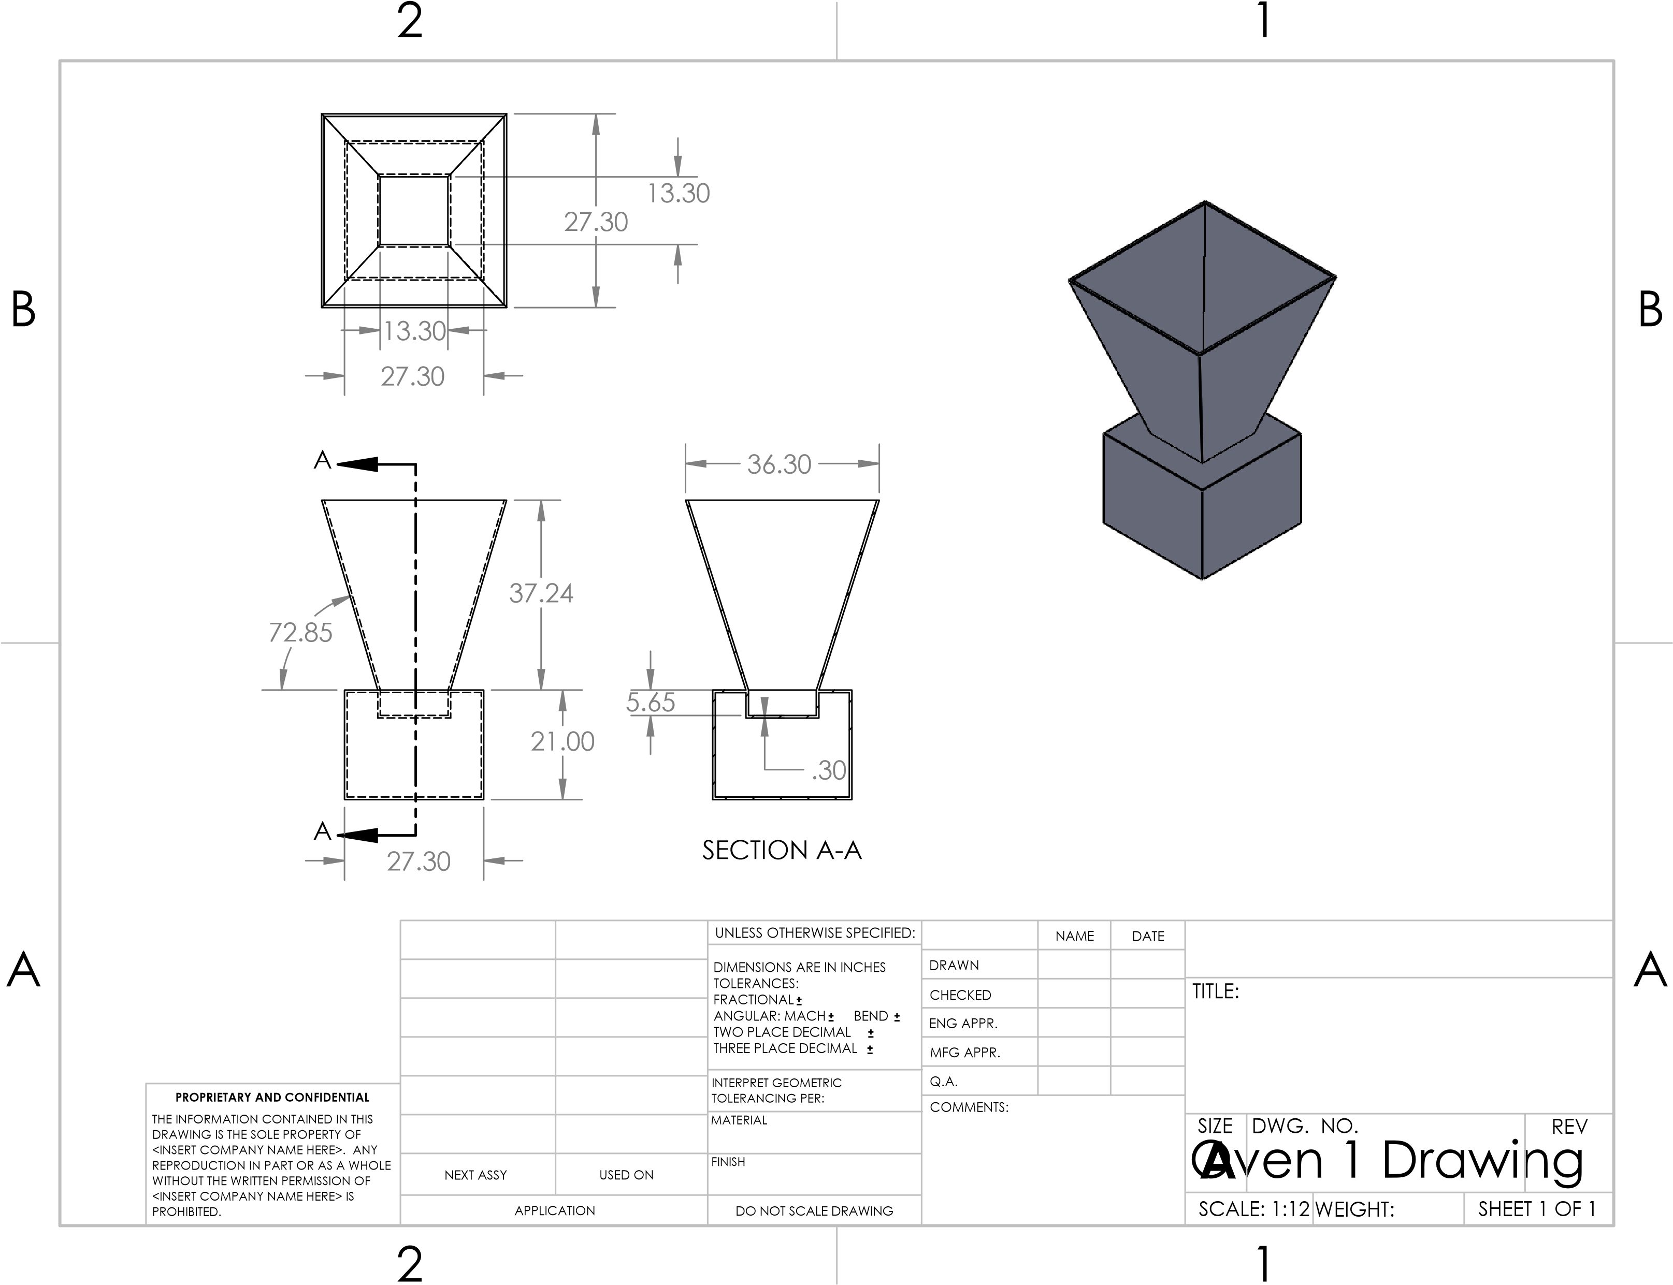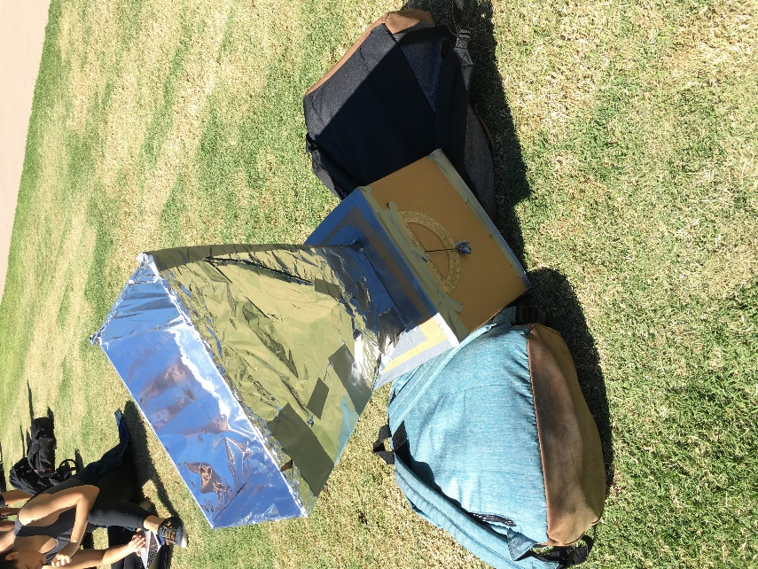

After analyzing the performance of the first solar oven, it was apparent that changes needed to be made to create an oven that produced a higher internal oven chamber temperature. For the second oven design, it was decided that the oven chamber and window dimensions would stay the same, as they were practical measurements that maximized the oven window while still allowing a biscuit to fit inside. Therefore, the chamber was still 5.65 cm deep and the window length and width remained at 13.3 cm. This large window length would allow the most possible sunlight to enter the chamber.

In contrast, the reflector dimensions had to be adjusted to maximize reflectivity of sunlight through the oven window. The group agreed that the reflector length should be made to be as long as possible, because an increased reflector size would result in an increased amount of sunlight entering the chamber. The result was making the length of the reflectors 39.9 cm, which satisfied the maximum M/L ratio of 3 when the window length was kept at 13.3 cm. This change in reflector sized caused changes in both the angle of sunlight with respect to the reflectors α and the angle of the top surface of the oven (the lid) with respect to the reflector Ω. The lid angle slightly shifted to 106.3°, and thus α was changed to 16.3° to maximize the amount of sunlight entering the chamber. More care was taken while cutting out the cardboard reflectors for the second oven, and a box cutter was used to get straight edges rather than rough. The result was crisp, even reflectors that were accurate in producing the 106.3° angles with the top of the oven chamber.

The method used to align the oven with the sun still consisted of using a backpack to tilt the oven, but no protractor was connected to the oven for the second design. Instead, correct β angles throughout the testing of the second oven were found by placing a protractor’s flat edge on the ground and tilting the oven to the desired angle. This avoided confusion that connecting the protractor to the oven would have produced.

Another variable that was improved for the second oven design was the size of the outer box, and thus the amount of insulation surrounding the oven chamber. As the group discovered that 7 cm of insulation was not sufficient in keeping heat from escaping through the oven, it was decided that more insulation should be added; however, if too much insulation were to be added, the same effect of heat loss would occur and the cost of the oven would rise as well. Therefore, the new insulation thickness became 9.00 cm, resulting in the outer box dimensions being 31.0 cm x 31.0 cm x 21.0 cm. The insulation used was kept constant, but the newspaper used was shredded into smaller pieces compared to what was used in the first oven. Still, it is important to note that the insulation thickness was not perfect, for it was made too large underneath the oven chamber. Since the top of the oven chamber was completely flush with the top of the outer box (a hole in the outer box the same size as the chamber allowed the chamber to fit perfectly within the outer box), 9.00 cm of insulation added to the 5.65 cm depth of the chamber should have made the outer box depth to become 14.65 cm instead of 21.0 cm. This inaccuracy most likely had a contribution to the second oven not reaching its predicted temperature.

Another variable that caused the actual oven chamber temperature to differ from the predicted was heat loss through gaps between the reflectors and oven chamber. In both ovens, the same hinge method for the reflectors was used to access the oven chamber and the window was connected to the bottom of the reflectors. Therefore, the same issue of heat loss through the gaps of the chamber and reflectors was present, only worse on the day of the test for the second oven. About 25 minutes into the test, the duct tape holding the top reflector to the oven lid melted due to the intense heat inside the oven chamber. This caused a larger gap to from between the chamber and reflectors when the oven was angled towards the sun, allowing more heat to escape. Despite this inconvenience and the incorrect insulation measurement, the modifications made to the reflector size and outer box dimensions allowed the second oven to reach 142 °C. This was a success because even with a large amount of heat loss through the top of the oven, the second oven’s highest chamber temperature was more than 11°C higher than the first oven’s maximum chamber temperature.

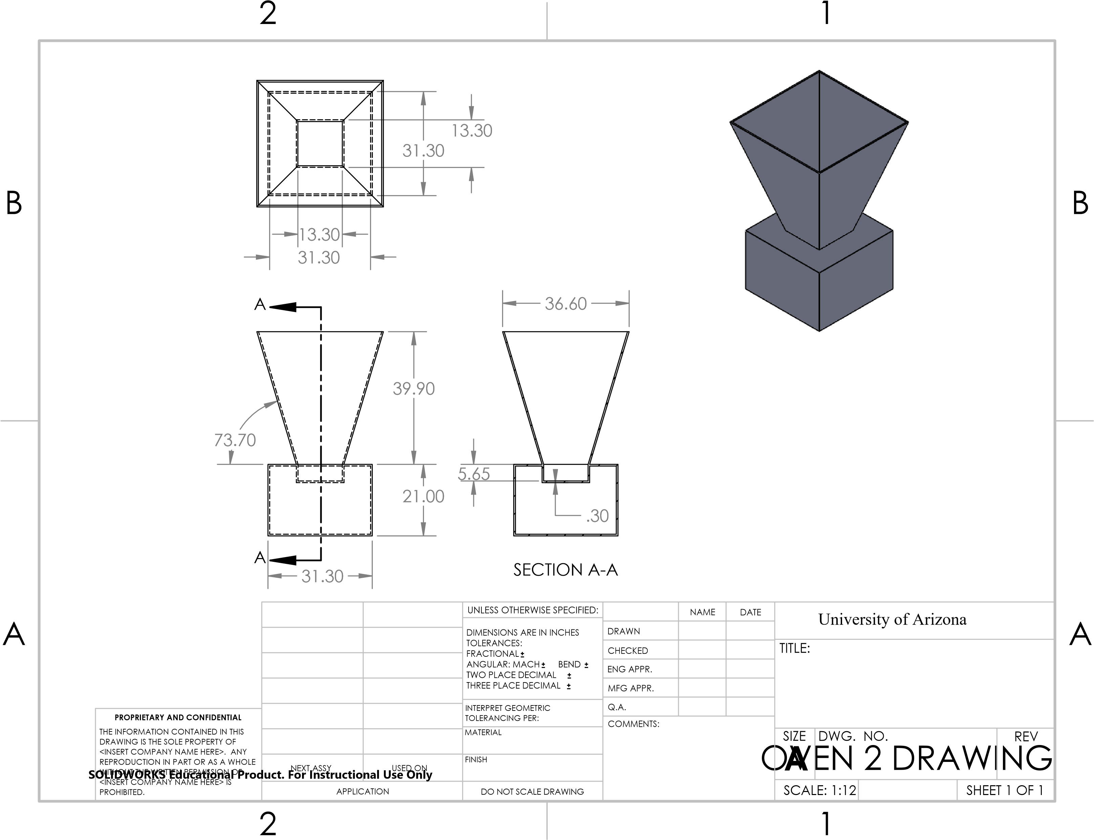

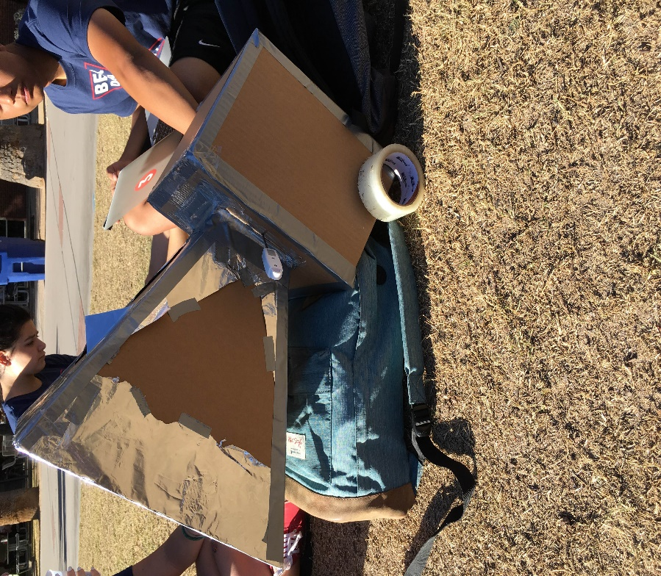

**Design Justification**

**Oven 1:**

For the first oven, the design included an oven chamber of dimensions 13.3 cm x 13.3 cm x 5.65 cm to satisfy the maximum oven chamber of 1000 cm3. These dimensions were chosen to make the oven window as large as possible without losing functionality with respect to fitting a biscuit inside the chamber. This small chamber was surrounded by a larger box of dimensions 27.3 cm x 27.3 cm x 21 cm, which resulted from miscommunication of calculations between team members. This smaller than expected outer box caused the insulation thickness to be half as big as was needed to reach the predicted chamber temperature. The insulation used was wadded newspaper, and it was chosen because not only was it available and a very low cost (free), newspaper has a relatively low thermal conductivity at .123 W/(m2*˚C) as given by the Solar Oven Basics Document. Since materials of low conductivity prove to transfer heat poorly, newspaper would prevent heat from escaping through the chamber and out of the larger box. Aside from miscalculations, a major component of the first solar oven that led to its poor performance was poor craftsmanship. Rough edges around the reflectors caused complications when taping them together and this resulted in too large of an angle between the oven window and reflectors. This issue, combined with crinkled foil, caused the reflectors to not reflect the needed amount of sunlight through the oven window to reach the predicted chamber temperature (or Tio value).

**Oven 2:**

After changes were made from the first oven, the second solar oven proved to be more successful in reaching its predicted temperature. Although the same type of insulation was used with the same thermal conductivity in both ovens, the newspaper in the second oven was shredded into smaller pieces, allowing more newspaper to be compressed into the larger box and to surround the chamber. A higher quantity of a low conductivity substance would result in an even smaller amount of heat transfer out of the oven, and therefore would conserve more heat inside the oven. In addition, the insulation thickness was increased to 9 cm to further the effect against heat transfer out of the oven. This increased insulation thickness increased the larger box as well, making the new dimensions 31.3 cm x 31.3 cm x 21 cm. The chamber dimensions in the second design were kept the same as the first oven because it was agreed upon that the maximum window area was already reached without sacrificing chamber depth. Furthermore, other aspects of the second oven that contributed to its success stemmed from improved craftsmanship. For example, clean cuts of cardboard from a boxcutter allowed for the optimal lid angle Ω of 106.3 to be reached. According the Solar Oven Basics Document, having a correct predicted lid angle would allow as much sunlight to penetrate the window as possible, resulting in a hotter oven chamber. Finally, the use of a protractor not connected to the oven allowed for more accurate angles of the oven with respect to the ground β, which aligned the sun’s rays perpendicularly to the oven window and allowed more sunlight to enter to window as well. Improved craftsmanship, fixation of mistakes, and increased exposure to the sunlight all contributed to the increased success of the solar oven in the second design.

**Test Procedure**

The in-class testing took place outside the museum located on campus. In order to determine a proper Tio for the specific day both the Gould-Simpson building and sun degree angle websites were utilized. By plugging the specific Io and Tambient values in our Excel spreadsheet, we were able to determine that our oven should reach an internal temperature of 193oC. In order to angle the reflectors to create the 90° angle necessary between the sun rays and the reflectors a protractor was used to get the correct angle. Through the use of backpacks and notebooks, the oven was leaned forward in order to heat up the oven chamber. A biscuit was placed within the oven chamber along with the tip of the thermometer, both useful for determining whether or not the oven chamber was heating up, the biscuit being qualitative data and the thermometer quantitative.

The following is a table for the results seen after the first solar oven test which was held on 09/24/16.

|  |  |
| --- | --- |
| PICost | 10.81 |
| PISOTD | 2.03 |
| Predicted Tio (℃) | 194.4 |
| Highest Tio (℃) | 131 |

|  |  |  |
| --- | --- | --- |
| Time (AM) | Tambient (℃) | Io (W/m2) |
| 11:00 | 23.7 | 942.7 |
| 11:30 | 24.5 | 640.5 |
| 12:00 | 23.3 | 590.2 |

The following is a table for the results seen after the first solar oven test which was held on 10/20/16.

|  |  |
| --- | --- |
| PICost | 4.73 |
| PISOTD | 3.57 |
| Predicted Tio (℃) | 190 |
| Highest Tio (℃) | 142 |

|  |  |  |
| --- | --- | --- |
| Time (PM) | Tambient(℃ ) | Io (W/m2) |
| 3:30 | 58.0 | 880 |
| 4:00 | 133 | 780 |
| 4:20 | 142 | 662 |

**Test Results**

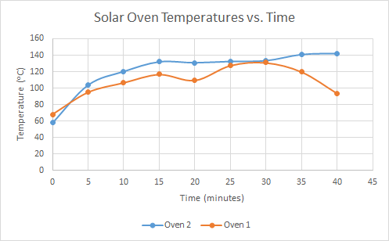

Both solar ovens were successful in their own way. The first solar oven reached its highest temperature of 131 oC roughly 30 minutes into the test run. The cost-based performance index was 24.88 and the overall SOTD performance index was 2.034. Unfortunately, 131 oC did not match our predicted oven interior temperature of 194.4 oC. We believe this large gap in temperature was due to various factors, such as wrinkled reflectors, non-sealed oven chamber, and incorrect angles of the oven in comparison to the sun. A major design flaw in our initial oven build became apparent when our reflectors completely collapsed just over 30 minutes into the test due to high winds. Not only was wind a factor in cooling the oven, but heat was quickly lost during this structural failure. It was then agreed that we needed a new reflector design. We decided that our final oven design needed to be more structurally sound to see an increase in temperature.

The second and final solar oven outperformed our first oven, which was expected. The highest internal oven temperature reached was 142oC at the final 40-minute mark. Our predicted interior oven temperature for the second oven was like the first oven, which was calculated to be 193.2 oC. Again, there was still a large gap between our highest temperature reached and our predicted temperature, but this test was more successful than the first. The cost-based performance index for this second oven was 4.73 and the SOTD performance index was 3.57. This gain in temperature of 11 oC is due to our new and improved reflectors and overall oven design structure. Our reflectors were smoother and much more secure with extra tape. Although, we assumed that the improved design and lack of wind on the test day would have a greater impact on our oven temperature. Unfortunately, we still had issues in regards to finding the correct angles to lean our oven to maximize the effectiveness of the reflectors.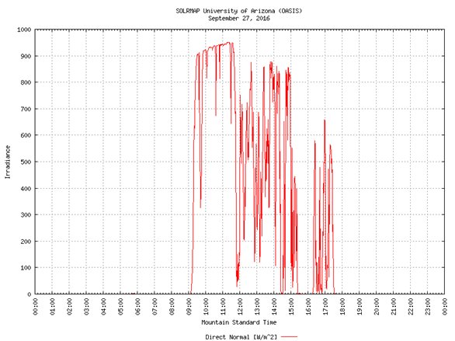

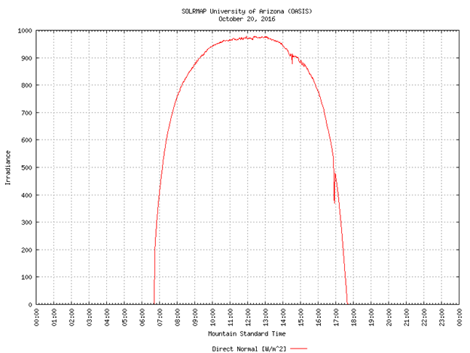

Both test days experienced extremely different levels of Io and both plots indicate the irradiance in relation to time throughout the day. The first plot shows the first test day on September 27, 2016. This initial solar oven was tested between 11:00 AM and 12:00 PM. Between this time the Io had a sporadic change and could account for our dip in temperature with the first oven. The plot on the right indicates the second oven test which took place between 3:30 PM and 4:30 PM. According to the plot, between the testing times the Io quickly decreased. It is difficult to produce an updated and accurate model prediction with these constantly changing Io values. We decided to get major readings every half an hour to determine a proper prediction.

Neither oven reached the predicted oven interior temperature, but as expected, the second oven improved in relation to the first oven. The first oven showed experienced various dips in temperature, while the second oven relatively increased throughout the entire test. In conclusion, the second and final oven design was the most successful and optimal of our two designs as it reached a temperature of 142oC which is greater than the first oven that peaked at 131oC.

**Team Dynamics**

Our team was structured such that, there was no overbearing leader, but rather four people coming together with different opinions in order to complete the task at hand. Everyone’s opinion was heard, and from that the plan was developed for how our team was going to accomplish designing and building the solar oven. In terms of actual construction each person was given a section of the solar oven whether that was the outer box, reflectors, or oven chamber and then with each separate part, we pieced them all together into our final product. Isabella Martinez-Lugo was an active member of the group “Team Baked” and was responsible for the supplies along with designing and constructing the oven specifically the reflectors. Jarod Yancy brought to the team help in both design and construction of the outer box dimensions and optimizing the oven dimensions to help generate the highest internal temperature possible. Shelby Nelson aided the group by inputting her opinion on the oven chamber and window dimensions along with the construction of the inner oven chamber a crucial component of the oven. Joshua Silverio helped the group by calculating the internal oven temperature through the Excel model along with constructing the foil over the reflectors and portions of the outer oven box.

**Design Critique and Summary**

Most of the flaws in our oven can be categorized under lack of resources. When building the oven, technique was very important and since we had never built one before or anything like it, our technique was very sloppy. We learned by trial and error in terms of what worked and what did not when measuring, cutting, and taping the cardboard together, as well as the mylar sheets. Had we had more materials, we would have had more room for developing a technique which would produce more precise oven parts. After dissecting Team #4’s oven, we were able to come up with a list of strengths and weaknesses in terms of what help can help an oven achieve a higher temperature and what can prevent one from doing so. Having smooth foil on the reflectors is extremely important when building the oven because if the aluminum foil has crinkles in it, it will not be able to reflect the sunlight as well as aluminum foil which is smooth. Team #4’s outer box was covered in black paper. We should have covered our oven in black paper as well because black paper absorbs light and this could have caused our internal oven temperature to increase significantly.

To future teams, we would recommend keeping in mind that precision and technique during the construction process are extremely important because any laziness or oversight could be detrimental to your desired results. Although a cooking rack is not required, we would recommend to build some sort of oven rack to optimize the cooking conditions within the oven chamber. In order to maximize one’s cost performance index, we would recommend to limit your use of tape and tinfoil because unnecessary usage of these materials could lower your performance index. Although this is something you cannot control, testing an oven under “optimal conditions” would increase your oven’s temperature so you better hope to have your Solar Oven Throw Down on a windless and sunny day.

**References**

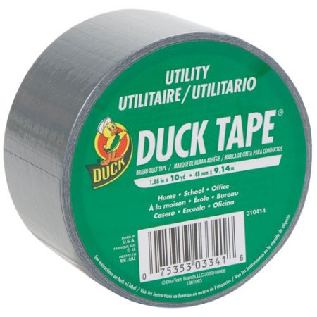

“Duck Brand Duct Tape, Utility, 1.88" x 10 yds, Silver.” Walmart.com N.p., n.d. Web 3 Nov. 2016.

https://www.walmart.com/ip/Duck-Brand-Duct-Tape-Utility-1.88-x-10-yds-Silver/17510794

**Appendices**

Excel Spreadsheet Data

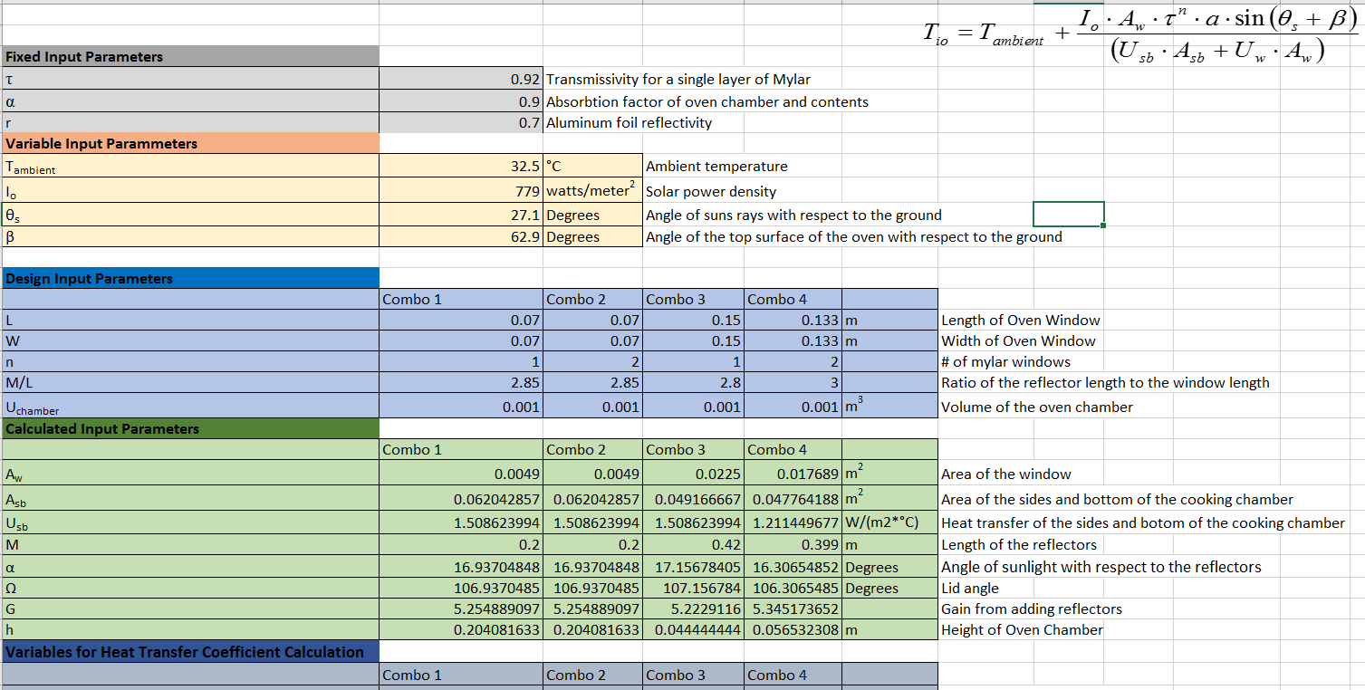

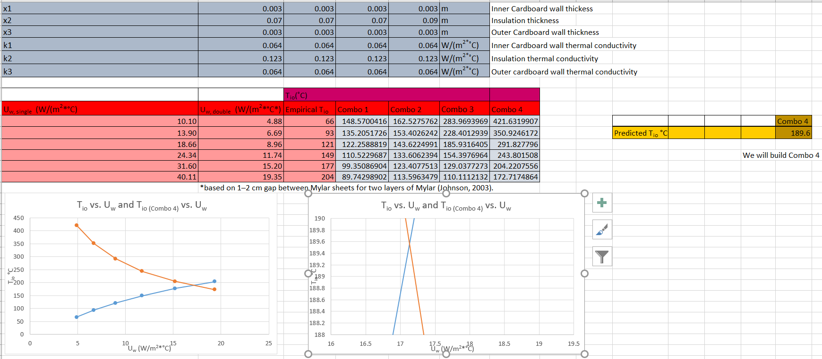

**Solar Oven Performance Index Details for Oven 1**

Materials

|  |  |  |  |
| --- | --- | --- | --- |
| **Specific Materials** | **Amount Used** | **Cost Basis** | **Cost for Amount Used** |
| Cardboard | 0.6246 m2 | $1.75/ m2 | $1.09 |
| Mylar Sheets | 2 | $0.25 each | $0.50 |
| Duct Tape | 40% of a roll | $5.00 | $2.00 |
| Aluminum Foil | 0.252 m2 | $0.55/ m2 | $0.14 |
| Black Paper | 1 | $0.03/sheet | $0.03 |
| **Total Material Cost:** |  |  | $3.76 |

Transportation cost: $0.36

Labor cost: fixed at $5.00

Performance Index: 2.034

Tambient =11:00 AM = 23.7℃; 11:30 AM = 24.5℃

Tio = 131℃

PISOTD = 2.034

PICost = 10.81

**Solar Oven Performance Index Details for Oven 2**

Materials

|  |  |  |  |
| --- | --- | --- | --- |
| **Specific Materials** | **Amount Used** | **Cost of Material** | **Cost for Amount Used** |
| Cardboard | .7246 m2 | $1.75/ m2 | $1.26 |
| Mylar Sheets | 2 | $0.25 each | $0.50 |
| Duct Tape | 40% of a roll | $5.00 | $2.00 |
| Aluminum Foil | .272 m2 | $0.55/ m2 | $0.15 |
| Black Paper | 1 | $0.03/sheet | $0.03 |
| **Total Material Cost:** |  |  | $3.94 |

Transportation cost: $0.40

Labor cost: fixed at $5.00

Performance Index: 3.57

Tambient =11:00 AM = 33.1℃; 11:30 AM = 32.5℃

Tio = 142℃

PISOTD = 3.57

PICost = 4.73

Dissection

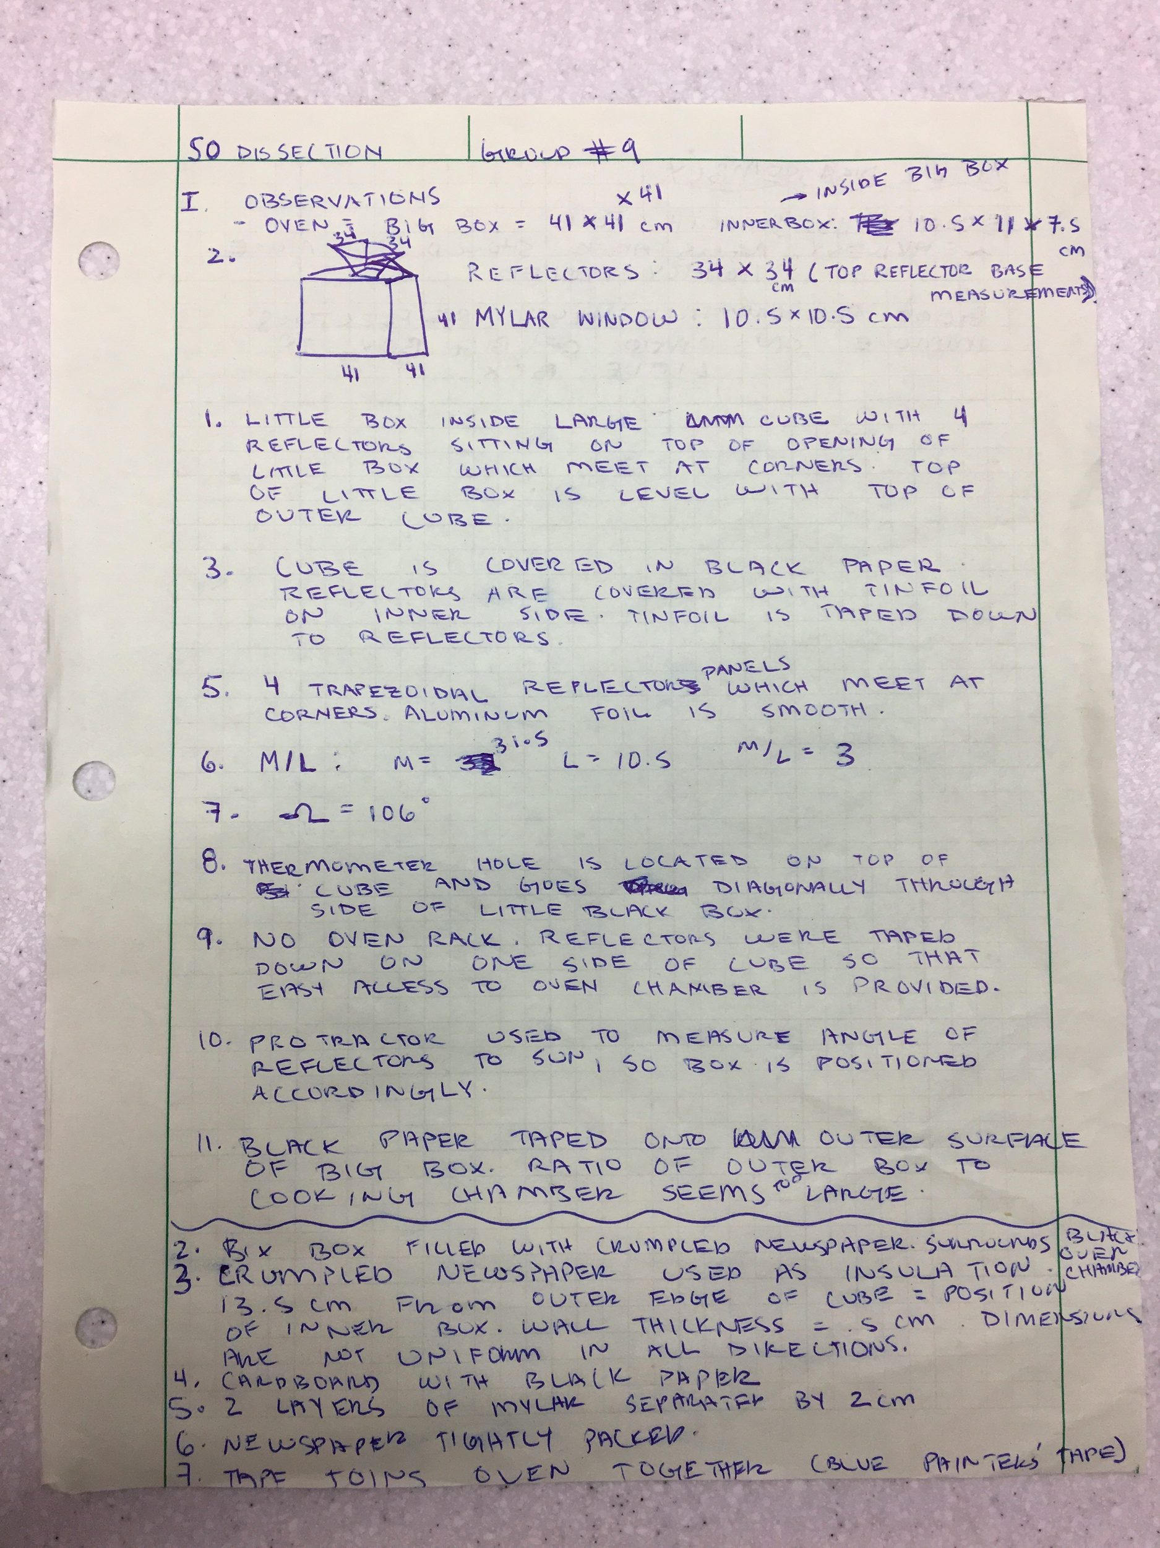

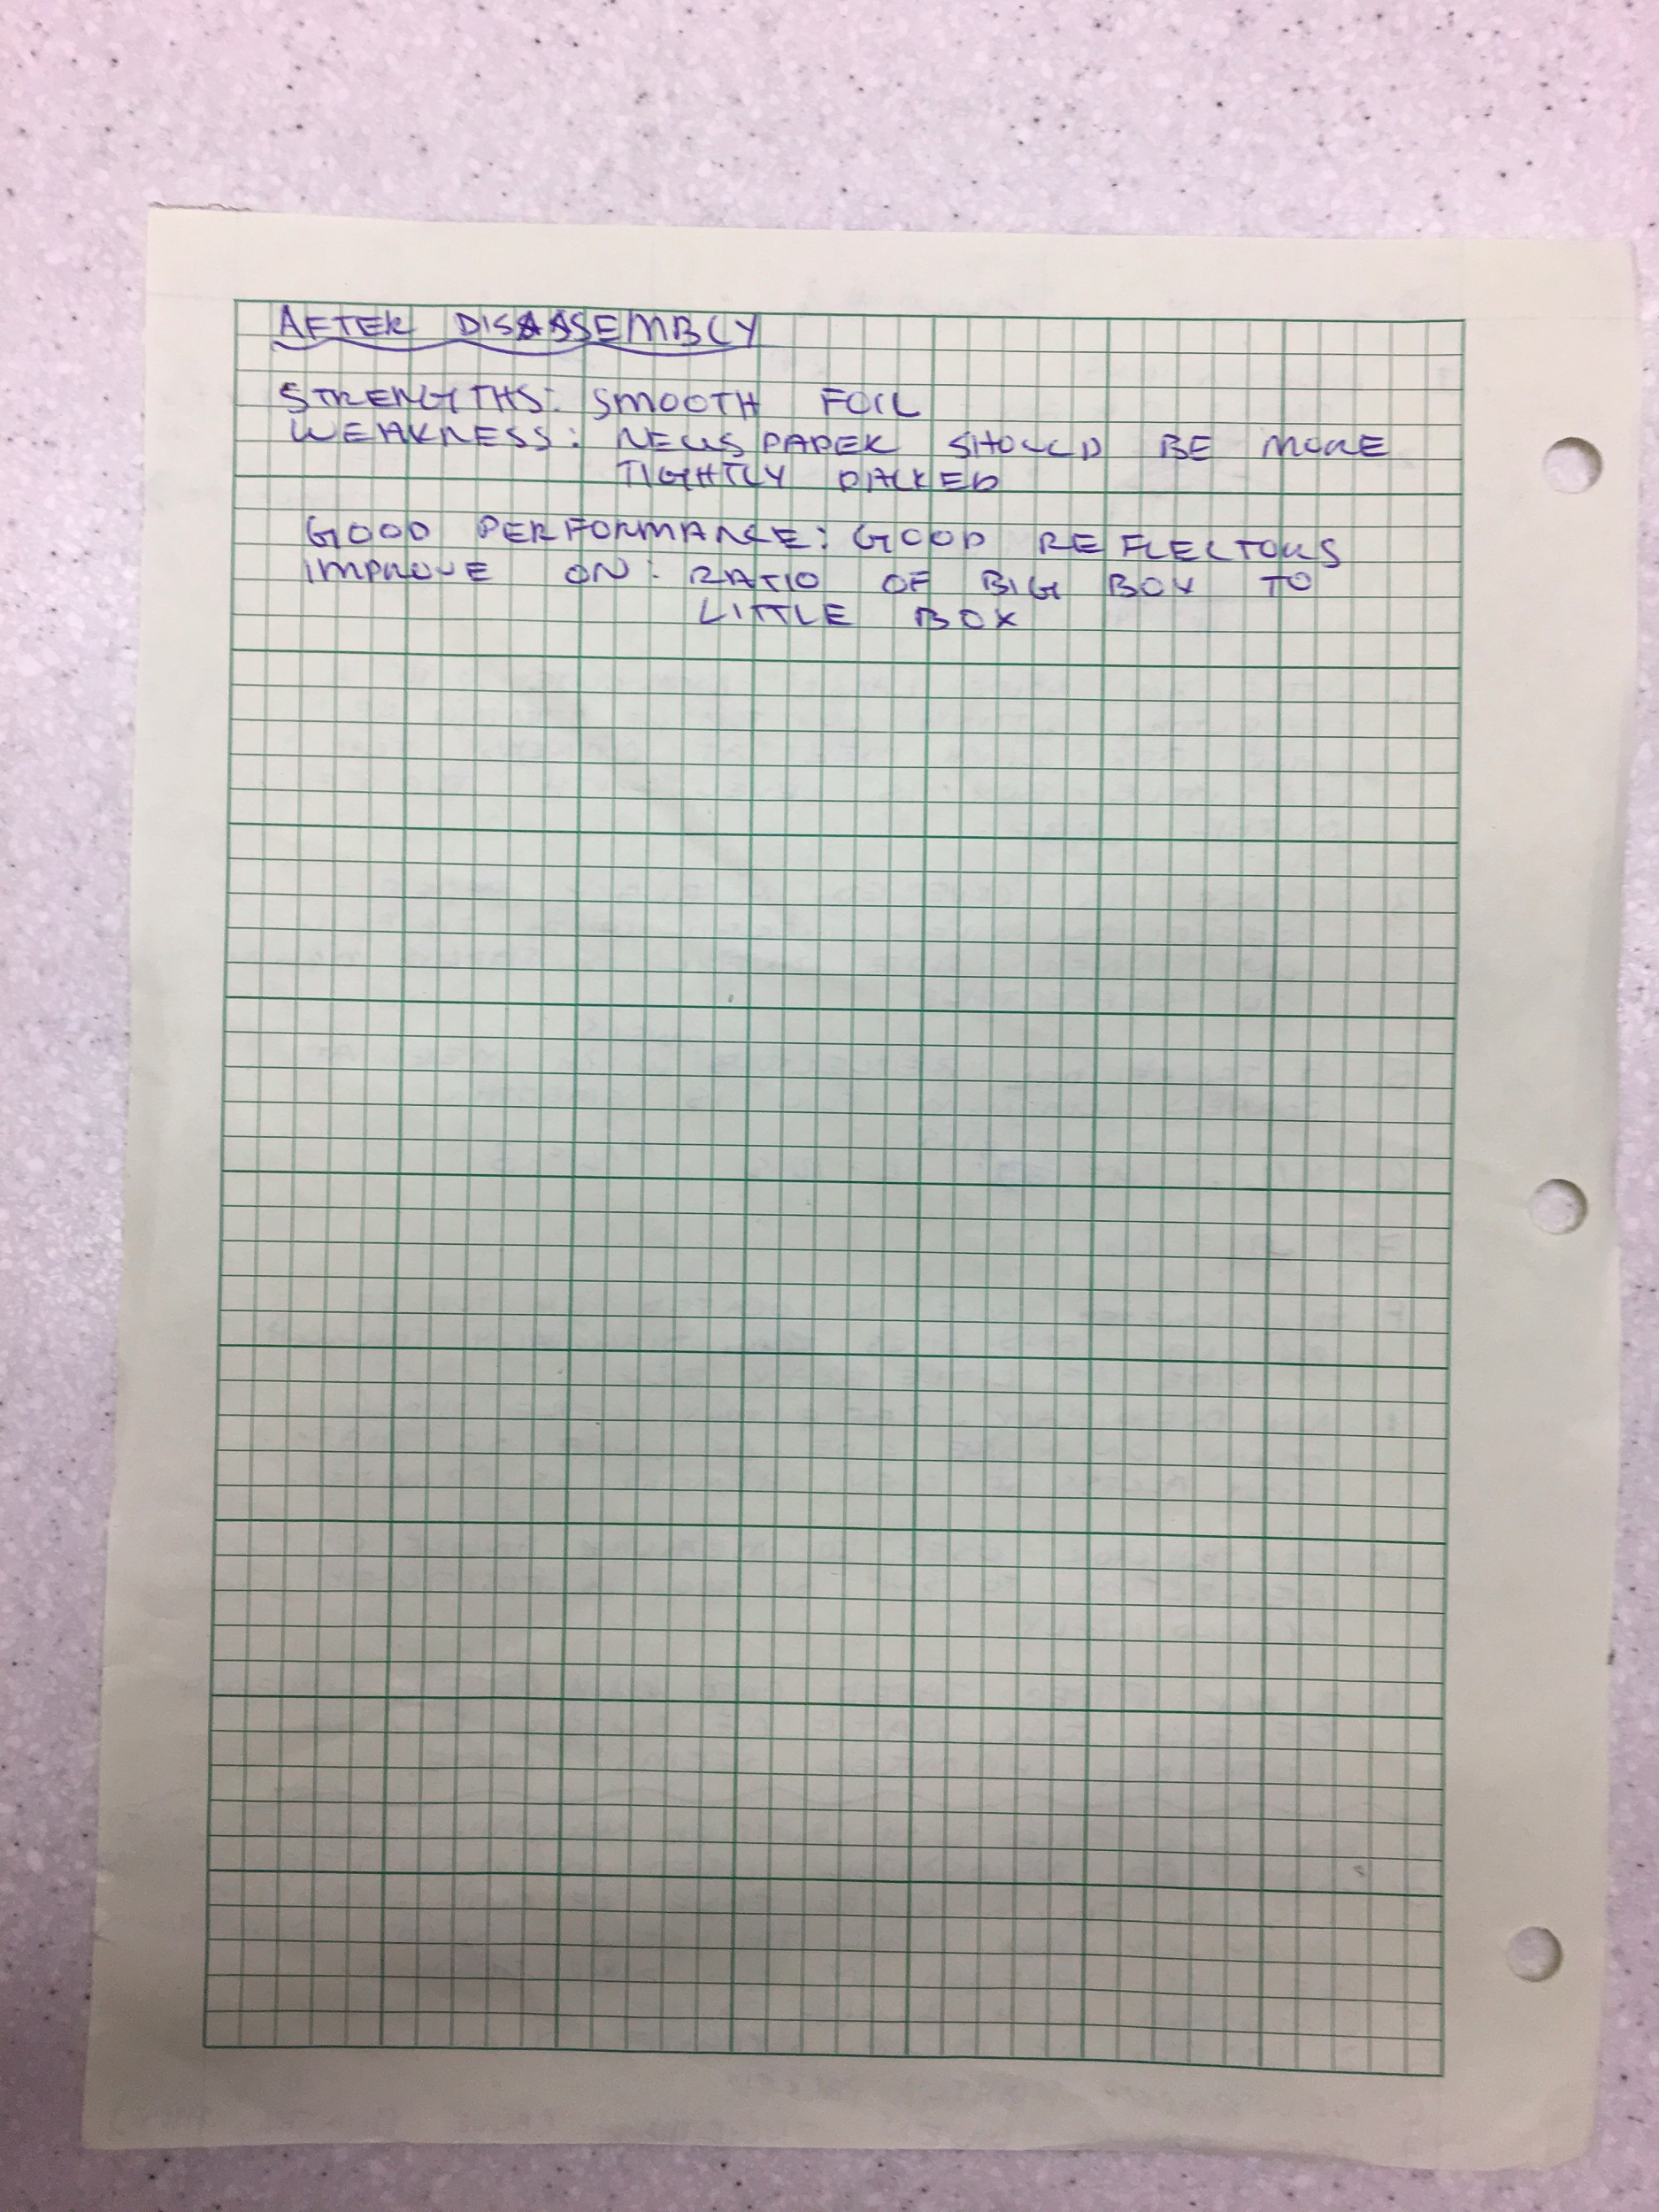

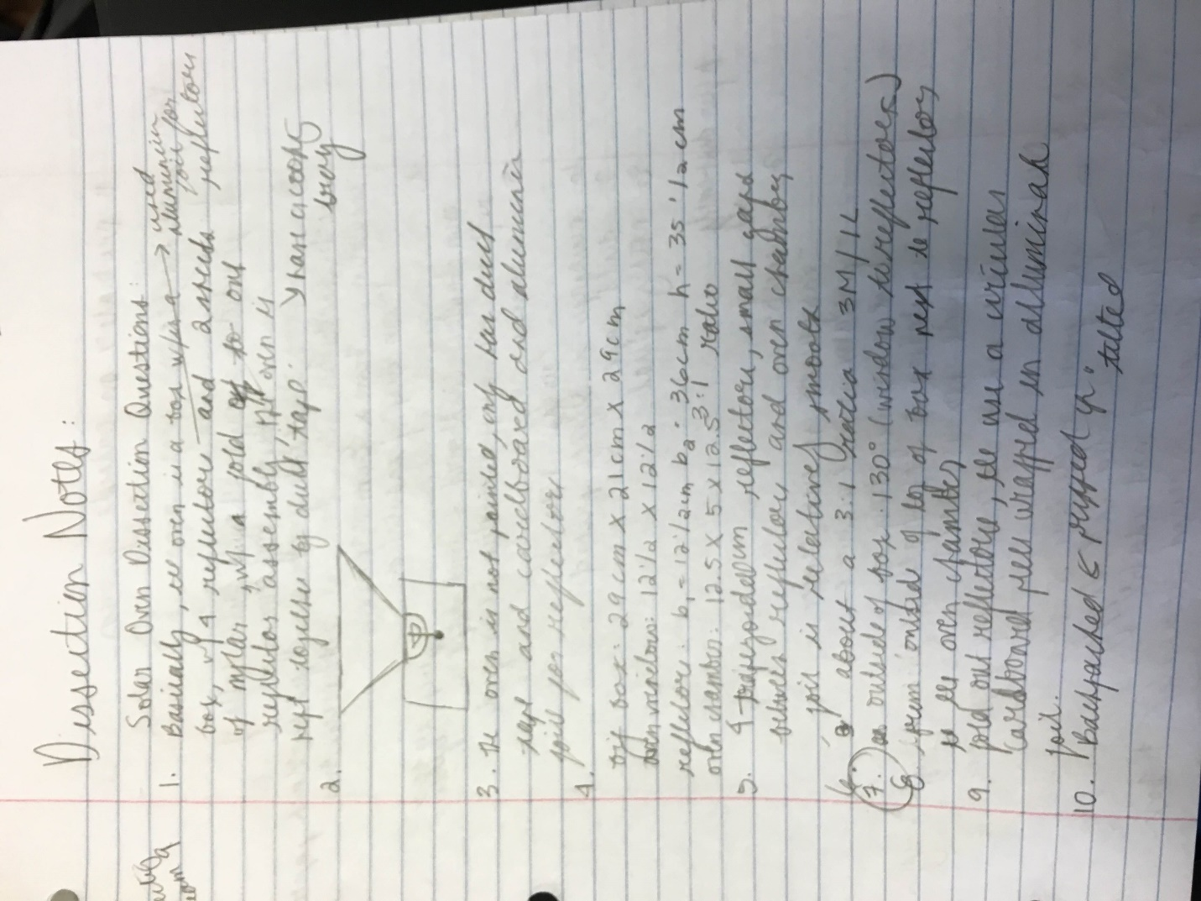

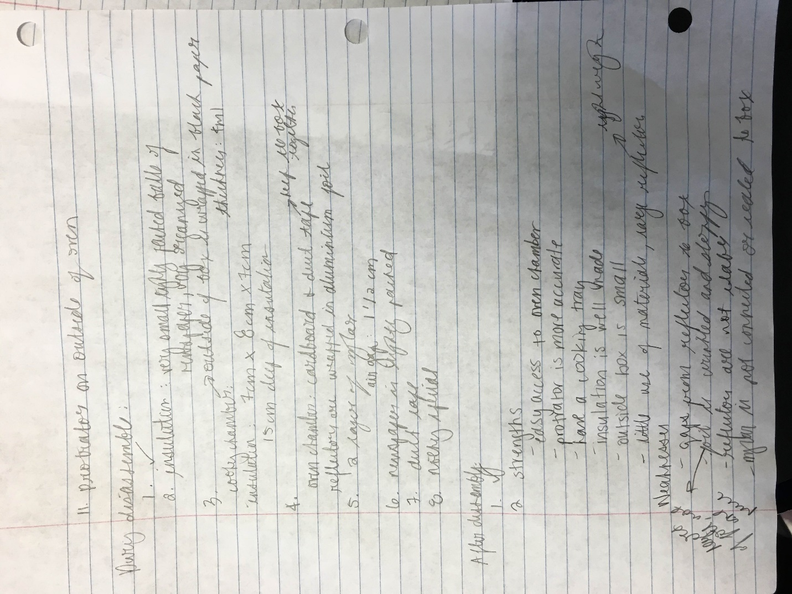

First Oven Testing Data

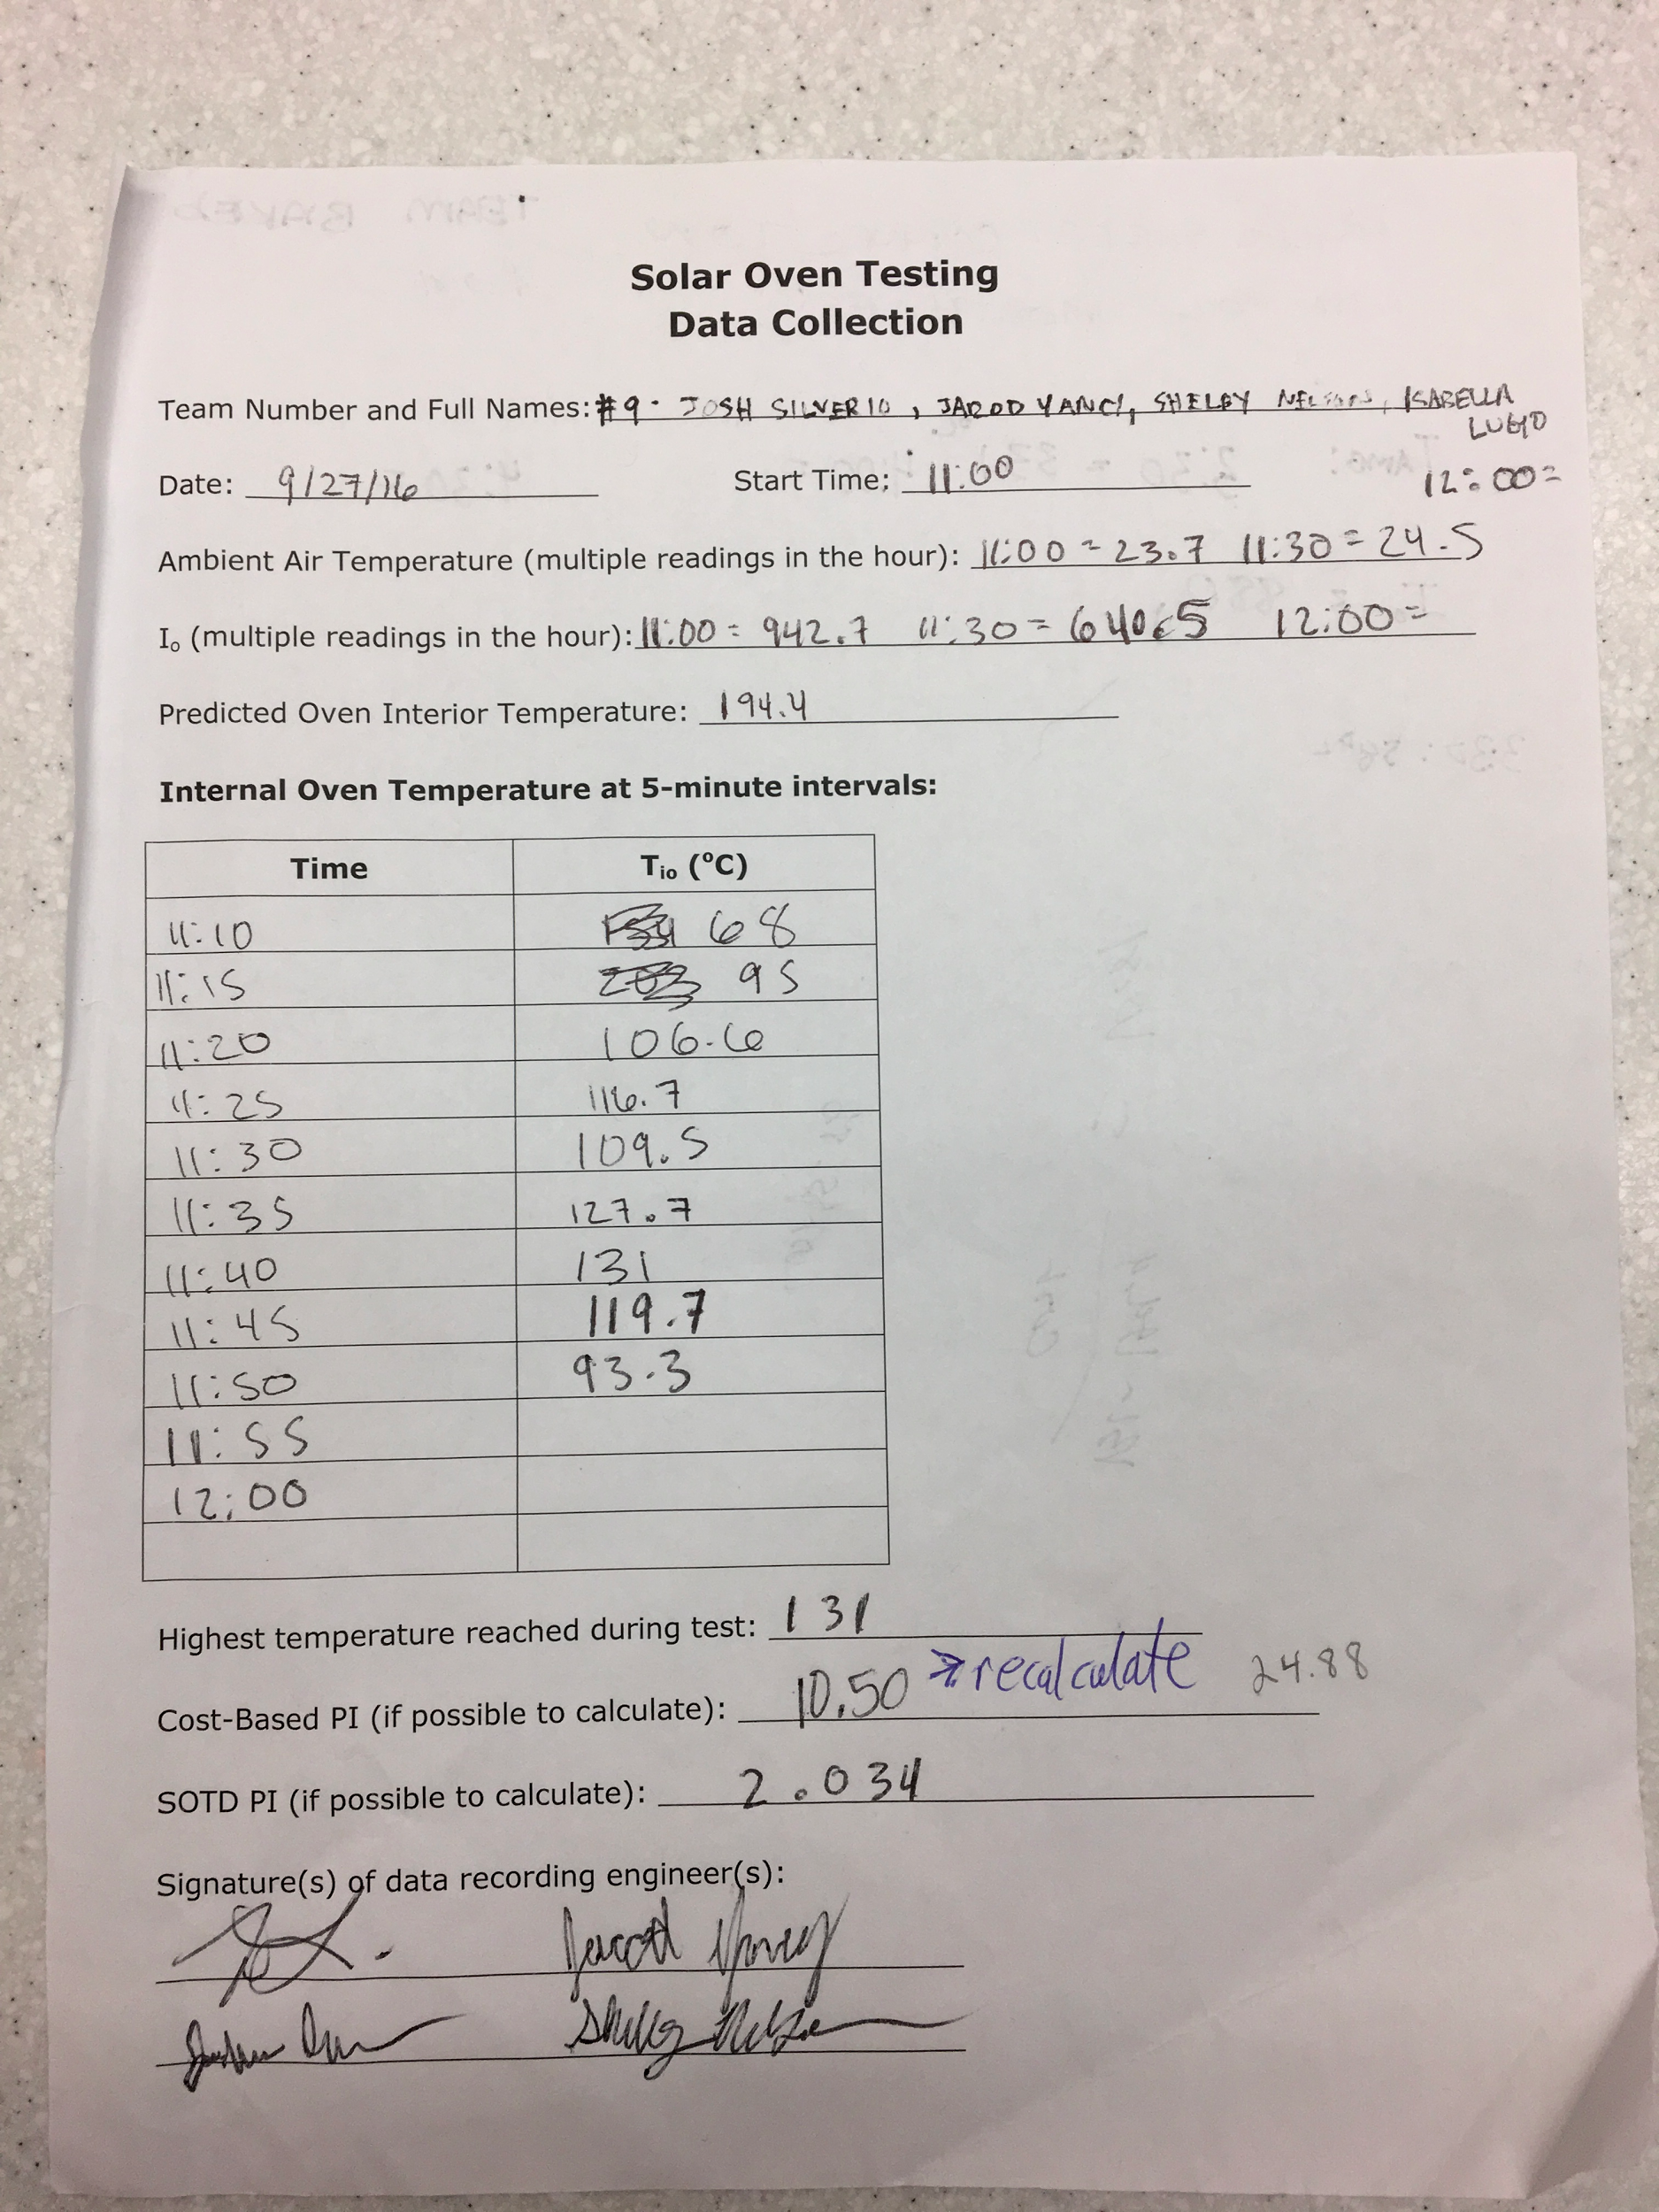

Final Oven Testing Data

